TOWN OF ELLENDALE
PLEASE NOTE THE LOCATION OF THE MEETING

TOWN COUNCIL- SPECIAL MEETING

Town Hall, 300 Mccaulley Avenue

December 5th , 2023 - 6:00 PM

AGENDA
- Call to Order
- Pledge of Allegiance/Moment of Silence
- Roll Call
- Approval of Agenda
- NEW BUSINESS:
  - 2024 Community Block Grant
  - Discussion and possible vote of Election Board Member(s)
  - Discussion and possible vote for Board of Adjustment Member(s)

- Recognition of Visitors-At this time, anyone wishing to address the Town Council may do so.
(Please note there is a two minute time limit and there is no rebuttal from council members or members of the public permitted.)

- Adjournment

Note: Pursuont to 29 Del.C. Section 10004(e)(2) Agenda items as listed may not be considered in sequence. This Agenda is subject to include additional items, including Executive Sessions, or the deletion of items including Executive Sessions, which arise at the time of the meeting. Section 5. F.Additional, FOIA authorize "the removal of any person from a public meeting who is willfully disruptive of the conduct of such meeting."

NOTE: All items on the Council Meeting Agenda are subject to a potential vote.

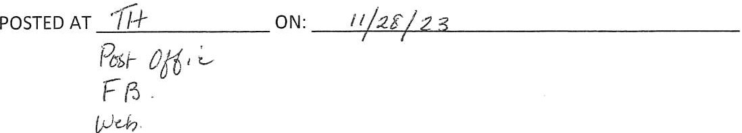
INITIALS A2

