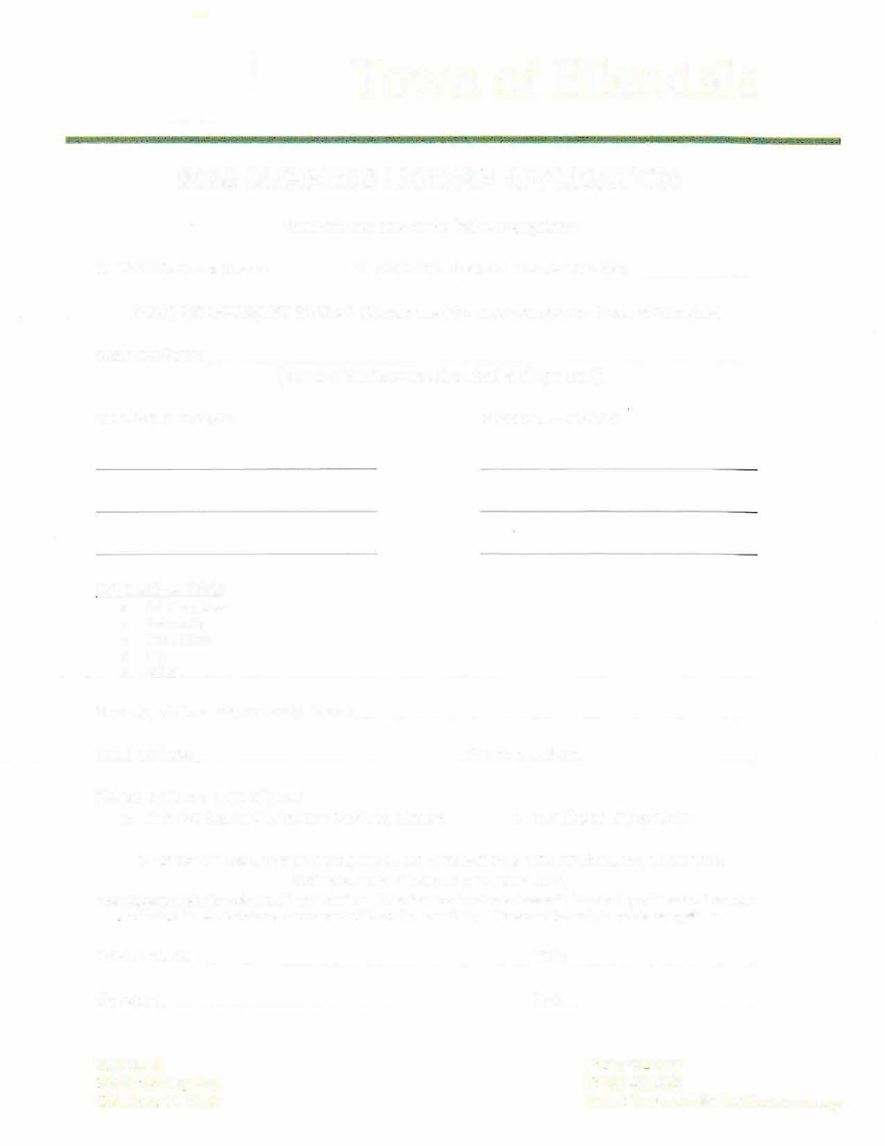

Town of Ellendale
2026 BUSINESS LICENSE APPLICATION
Please choose one of the following options:

0 NEW Business License
0 RENEWAL Business License Number: -------

BUSINESS LICENSE FEE $125.00 (Checks must be made payable to Town of Ellendale)

Business Name:
__
{Name of Business as advertised and operated)

MAILING ADDRESS: PHYSICAL ADDRESS:

OWNERSHIP TYPE:
- Sole Proprietor
- Partnership
- Corporation
- LLC
- Other

Name(s) of Owner{s) or Entity Name:
Email address: Phone Number:
Please enclose a copy of your:
- Current State of Delaware Business License o Certificate of Insurance

BY SIGNING THIS APPLICATION, I DECLARE UNDER PENALTY OF PERJURY, THAT THIS APPLICATION IS TRUE AND COMPLETE.
This application shall be submitted in conformity with Section 7.10 "Business Licenses" of the Zoning Ordinance of the Town of Ellendale. Work shall not commence within the Town until a valid Business License is issued to the applicant.

Printed Name Title

Signature _

P.O. Box 6
300 McCaulley Ave.
Ellendale, DE 19941
Date----------

P.: 302-422-6727
F: 302-422-0863
Email: Townclerk@ellendale.delaware.gov

